- Log into myUwindsor.
- Click on the mySuccess tab in the top left corner of the myUwindsor home page (see image below).
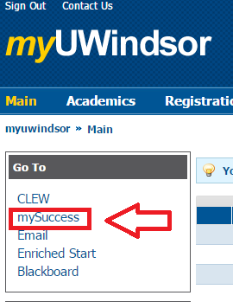
- Log into mySuccess with the same username and password you used for myUwindsor.
- Click on the ‘Writing Support’ tab in the top left corner (see image below).
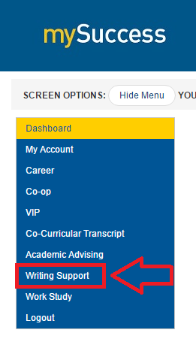
- Click on the ‘Events & Workshops’ tab that appears beneath the ‘Writing Support’ tab (see image below).
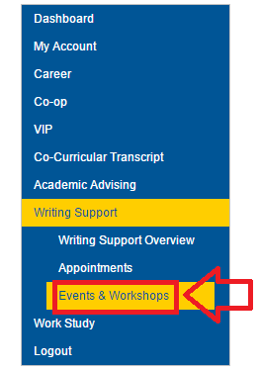
- On the calendar that appears to the right of the menu, click on the workshop you wish to attend (see image below).
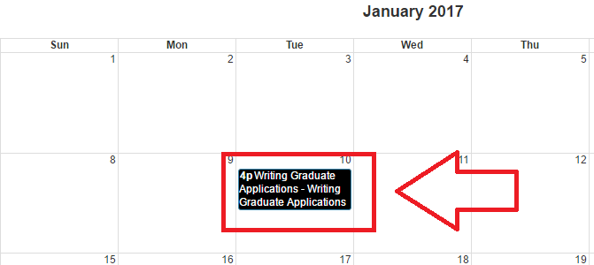
- On the page that pops up, click the blue button on the far right that reads ‘Register for this event’ (see image below).

