Provincial Digital Elevation Model (PDEM)
User Guide
  - Provincial Mapping Unit
  - Mapping and Information Resources Branch
  - Corporate Management and Information Division
  - Ministry of Natural Resources and Forestry
2020-04-08

Disclaimer
This technical documentation has been prepared by Her Majesty the Queen in right of Ontario as represented by the Ministry of Natural Resources and Forestry (the “Ministry”). No warranties or representations, express or implied, statutory or otherwise shall apply or are being made by the Ministry with respect to the documentation, its accuracy or its completeness. In no event will the Ministry be liable or responsible for any lost profits, loss of revenue or earnings, claims by third parties or for any economic, indirect, special, incidental, consequential or exemplary damage resulting from any errors, inaccuracies or omissions in this documentation; and in no event will the Ministry’s liability for any such errors, inaccuracies or omissions on any particular claim, proceeding or action, exceed the actual consideration paid by the claimant involved to the Ministry for the materials to which this instructional documentation relates. Save and except for the liability expressly provided for above, the Ministry shall have no obligation, duty or liability whatsoever in contract, tort or otherwise, including any liability or negligence. The limitations, exclusions and disclaimers expressed above shall apply irrespective of the nature of any cause of action, demand or action, including but not limited to breach of contract, negligence, strict liability, tort or any other legal theory, and shall survive any fundamental breach or breaches.
Cette publication spécialisée n’est disponible qu’en anglais.

Additional Information
This document does not comply with all the applicable guidelines for accessible digital documents. For an alternative format please email Provincial Mapping Unit at pmu@ontario.ca.
For more information about this document, please contact Provincial Mapping Unit at pmu@ontario.ca.

Executive Summary

Key Words
Digital Elevation Model, Digital Surface Model, Digital Terrain Model, cost path, elevation, terrain, topography, raw, interpolation, resample, unenforced, medium scale, orthoimagery, orthophoto.

Abstract
The Provincial DEM (PDEM) is designed to represent true ground elevation where possible across the province. Based on best available source data for different areas of the province, it is a general purpose dataset from which other special purpose datasets have been derived. This document provides a general description of the data sources used to create the PDEM, the structure of the dataset, as well as some data use and limitation considerations.

Revision History
Date | Edition/  Version | Description
2018-05-17 | 1.0 | First public release
2020-04-08 | 1.1 | Document references and hyperlinks updated

Table of Contents
Disclaimer 2
Additional Information 2
Executive Summary 3
Key Words 3
Abstract 3
Table of Contents 5
List of Figures 7
List of Acronyms 8
List of Definitions 10
Contour 10
Digital Elevation Model (DEM) 10
Digital Terrain Model (DTM) 10
Digital Surface Model (DSM) 11
Hydrologic Enforcement 11
Interpolation 12
Mass Points 12
1. Introduction 13
Versioning 14
2. Product Details 14
Spatial Representation and Geographic Extent 14
Horizontal Reference System 18
Horizontal Datum and Coordinate System 18
Horizontal Unit of Measure (coordinate system axis units) 18
Vertical Reference System 19
Vertical Coordinate System 19
Vertical Unit of Measure (coordinate system axis units) 19
Data Delivery 19
Elevation Products Available in Ontario 21
3. Elevation Sources and Interpolation 21
Source Elevation Data 21
Ontario Basic Mapping Elevation Data 24
Ontario Radar DSM (ORDSM) 25
All Other Elevation Updates 25
Water Bodies 26
Forest Vegetation 27
4. Recommended Data Uses and Considerations 28
Recommended Data Uses 28
Considerations 29
DEM Interpolation 29
Raster Merging and Mosaicking 29
DEM Maintenance 30
5. References 30
General References 30
Guideline References 31
Metadata References and Resources 31

List of Figures
Figure 1: Extents of the PDEM showing the divide just south of 50 degrees latitude between the northern and southern tiles 16
Figure 2: Location of St Marys Cement Quarry – the lowest point in southern Ontario – approximately 78m below the average level of nearby Lake Ontario 17
Figure 3: Extent of source elevation datasets used to create the PDEM. The inset shows where SWOOP forest surfaces were modified with OBM or GTA DTM data sources. Note this is strictly for illustrative purposes. Please consult the PDEM Spatial Metadata Index layer in LIO for the most current and accurate depiction of the product. 23

List of Acronyms
ANUDEM: Australian National University Digital Elevation Model software
ASL: Above Sea Level
CGVD28: Canadian Geodetic Vertical Datum 1928
CHS: Canadian Hydrographic Service
CO-OPS: Center for Operational Oceanographic Products and Services
CNT: Canadian National Transformation
DEM: Digital Elevation Model
DSM: Digital Surface Model
DTM: Digital Terrain Model
FOC: Fisheries and Oceans Canada
GTA: Greater Toronto Area
IfSAR: Interferometric Synthetic Aperture Radar
LCC: Lambert Conformal Conic
LIDAR: Light Detection and Ranging
LIO: Land Information Ontario
MNRF: (Ontario) Ministry of Natural Resources and Forestry
MSL: Mean Sea Level
NAD83: North American Datum of 1983
NASA: National Aeronautics and Space Administration
NOAA: National Oceanic and Atmospheric Administration
NRVIS: Natural Resources Values Information System
OBM: Ontario Basic Mapping
ORDSM: Ontario Radar Digital Surface Model
PDEM: Provincial Digital Elevation Model
PMU: Provincial Mapping Unit
SRTM: Shuttle Radar Topography Mission
WRIP: Water Resources Information Program

List of Definitions

Contour
A contour is a linear vector feature representing isolines, or lines of equal elevation, in metres above mean sea level.

Digital Elevation Model (DEM)
DEM is a generic term for digital topographic and/or bathymetric data that is comprised of x/y coordinates and z-values to represent an elevation surface.
The term ‘DTM’ and ‘DSM’ should be used over the term ‘DEM’ to more specifically reference ‘bare-earth’ or ‘surface elevation’ model products when possible.
The term ‘DEM’ is to be used as a broader term when referencing a generic elevation data product. The Provincial DEM is an example of a generic elevation product given that it has been constructed using a combination of both ‘DTM’ and ‘DSM’ elevation datasets to achieve Provincial coverage.

Digital Terrain Model (DTM)
The bare earth surface (lowest surface, last reflective surface, or LIDAR last-return) represents the surface of the "bare-earth" terrain, after removal of vegetation and constructed features.
Photogrammetry has traditionally generated DTMs when elevations are generated by manual compilation techniques. Unless specified to the contrary, the bare-earth surface includes the top surface of water bodies, rather than the submerged surface of underwater terrain.
Similar to a DSM, a DTM can be structured either as a vector dataset (comprised of mass points and optionally 3D breaklines) to model bare-earth elevations or a raster dataset that is interpolated from the vector elevation data to model bare-earth terrain elevations.
Using modern elevation point cloud classification algorithms and file formats, such as LAS, a DTM can represent a mass point dataset that has been classified for ‘bare-earth’ terrain elevations.

Digital Surface Model (DSM)
A DSM is the highest reflective surface of ground features captured by the sensor. This surface may also be referred to as the first reflective surface or LIDAR first-return. The DSM may include treetops, rooftops, and tops of towers, telephone poles, and other natural or manmade features; or it may include the ground surface if there is no vegetative ground cover. Photogrammetry, IfSAR, LIDAR and sonar can all provide this type of surface, yet characteristics such as accuracy and degree of detail (ability to resolve desired surface features) may vary significantly across technologies and even within the same technology. With sonar, the DSM may include sunken vessels and other artifacts, whereas the bathymetric surface reflects the natural underwater terrain. Similarly, with photogrammetry, LIDAR, and IfSAR the reflective surface may include any artifact present when the sensor mapped the area, including passing cars and trucks and similar features not normally considered to be part of a digital terrain model.
Similar to a DTM, a DSM can be structured either as a vector dataset (comprised of mass points and optionally 3D breaklines) to model surface elevations or a raster dataset that is interpolated from the vector elevation data to model surface elevations.
Using modern elevation point cloud classification algorithms and file formats, such as LAS, a DSM can represent a mass point dataset that has been classified for ‘surface’ elevation features.

Hydrologic Enforcement
Hydrologic enforcement is the process of conditioning a DEM to allow each cell to drain in a downward direction with barriers to flow being removed, where possible. The two main functions of hydrologic enforcement include clearing spurious sinks and ensuring that cells along streams decrease with elevation in a downstream direction.

Interpolation
The process of deriving elevations for a location on the Earth’s surface based on points where elevations have been measured. Many interpolation algorithms exist including natural neighbour, spline, inverse distance weighting, and kriging. Resampling to a different resolution (i.e. cell size) often involves re-interpolation.

Mass Points
Mass points are irregularly spaced points, each with x/y location coordinates and z-values, typically (but not always) used to form a TIN. When generated manually, mass points are ideally chosen to depict the most significant variations in the slope or aspect of TIN triangles. However, when generated automatically, e.g., by LIDAR or IfSAR scanner, mass point spacing and patterns depend upon the characteristics of the technologies used to acquire the data.

- Introduction
The Provincial Digital Elevation Model (PDEM) is a seamless 3-dimensional model that represents ground surface elevations in metres above sea level (ASL). The PDEM can be used for a number of applications such as landscape classification and general terrain analysis and has not been conditioned for any specific application.
DEMs are used for a broad range of studies including projects tied to the fields of geology, forestry, ecology, climatology, and hydrology. A DEM that more closely represents ground elevations, such as the PDEM, can be used to determine terrain attributes such as slope, aspect, or elevation at a specific location. DEMs are also used for remotely predicting geologic features such as fault lines, landforms and inferring material types. One of the main drivers and dependencies is the need for an elevation model to support the generation of Provincial integrated hydrology data. For hydrologic analysis, such as watershed generation and flow tracing, use of the Ontario Integrated Hydrology Data product is recommended (MNRF, 2012a). However, the PDEM can serve as a useful reference for watershed analysis particularly when unmodified ground elevations are required along river corridors, which are altered during the hydrologic conditioning process.
The PDEM has traditionally been compiled using some broad scale data sources derived from the Ontario Basic Mapping (OBM) program and NASA’s Shuttle Radar Topographic Mission (SRTM) including the Ontario Radar Digital Surface Model (ORDSM), OBM DTM, OBM Spot Height, and OBM Contour. Contours and spot heights had been used as interpolation sources where coverage of DTM data was lacking. Since then, the province has been continuing to incorporate best available data from newer elevation data acquisitions including but not limited to: 2002 GTA DEM, 2015 SWOOP DTM, and various recent LIDAR acquisitions in southern Ontario. For the majority of Ontario’s Far North region, the ORDSM was used to provide complete provincial coverage for the product.

Versioning
In order to meet broader end-user needs and maintenance requirements, the PDEM is now produced seamlessly for the province. The older tiled versions of the PDEM have been retired.
Version numbering for the PDEM is no longer supported. Instead all versioning information is now tracked in what is referred to as the ‘PDEM Spatial Metadata Index’, which stores the data source used and the date the data source was incorporated (see section 3 for more information).
- Product Details

Spatial Representation and Geographic Extent
A raster grid is used to represent the DEM where each raster grid cell has a single elevation value associated. The regular grid spacing is based on the Lambert Conformal Conic (LCC) projection with a raster cell resolution of 30 metres across the entire extent of the province.
The DEM is divided into 2 regions called “PDEM North” and “PDEM South”, both snapped to the nearest 30m at the origin. The horizontal extent of the data provides continuous spatial coverage for the entire province of Ontario. The approximate bounding extent for the data set is:
- West-bounding coordinate: -96 degrees longitude
- East-bounding coordinate: -74 degrees longitude
- North-bounding coordinate: 57 degrees latitude
- South-bounding coordinate: 41 degrees latitude
Some notable extent enhancements include the following:
- Areas were added beyond the provincial border which drain into northern Ontario to support community-based planning initiatives for indigenous communities in the far north;
- The entire Rainy River Basin was added to support various activities such as water quality analysis (IJC SPARROW nutrient loading modeling), water quantity analysis (OFAT and USGS StreamStats online tools), and watershed delineation (IJC International Watersheds Initiative) occurring along the international border;
- The geographic extent of the Great Lakes has been captured primarily as an aesthetic addition to the PDEM. However, the lake flattening applied honours the long-term average lake levels reported in partnership by Fisheries and Oceans Canada – Canadian Hydrographic Service (FOC-CHS) and the U.S. National Oceanic and Atmospheric Administration – Center for Operational Oceanographic Products and Services (NOAA-CO-OPS).
See Figure 1 for more extent details.

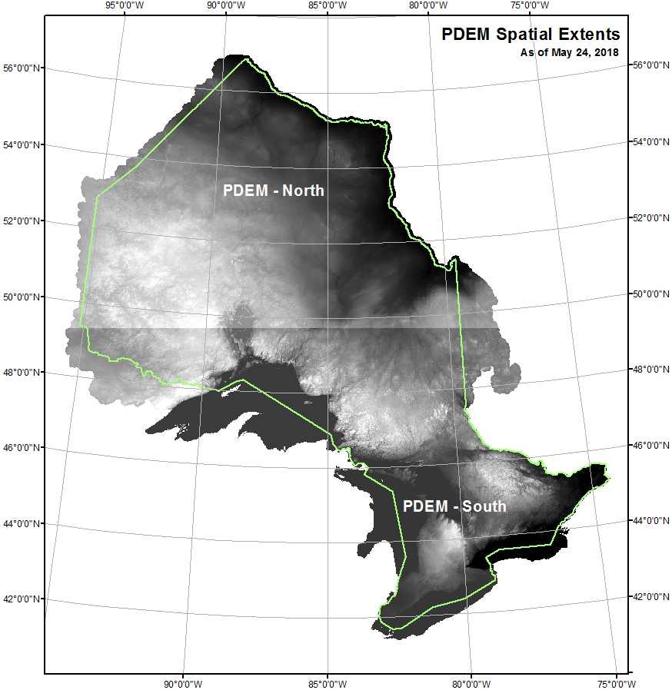
Figure 1: Extents of the PDEM showing the divide just south of 50 degrees latitude between the northern and southern tiles
The vertical extent of the dataset is expressed in metres. The lowest vertical extent naturally occurs along the coast of James Bay and Hudson Bay which reaches the elevation of mean sea level (MSL). However, there are select areas of the province where the elevation can drop below MSL which is typically caused by anthropogenic influences. For example, the St. Marys Cement mine in southern Ontario is the lowest point recorded at 1.54m below MSL (see Figure 2). The highest vertical extent of the PDEM is 688.23 metres ASL, located at Ishpatina Ridge (47.320N, 80.750W) in Lady Evelyn-Smoothwater Provincial Park located approximately 70 kilometres west of the town of Latchford. Note another source estimates this point to be approximately 693m ASL (NRCan, 2009). The difference can be attributed to the rounding effect of the ANUDEM interpolation process and is within the stated accuracies for OBM data sources (see the Interpolation Process section below for more details).
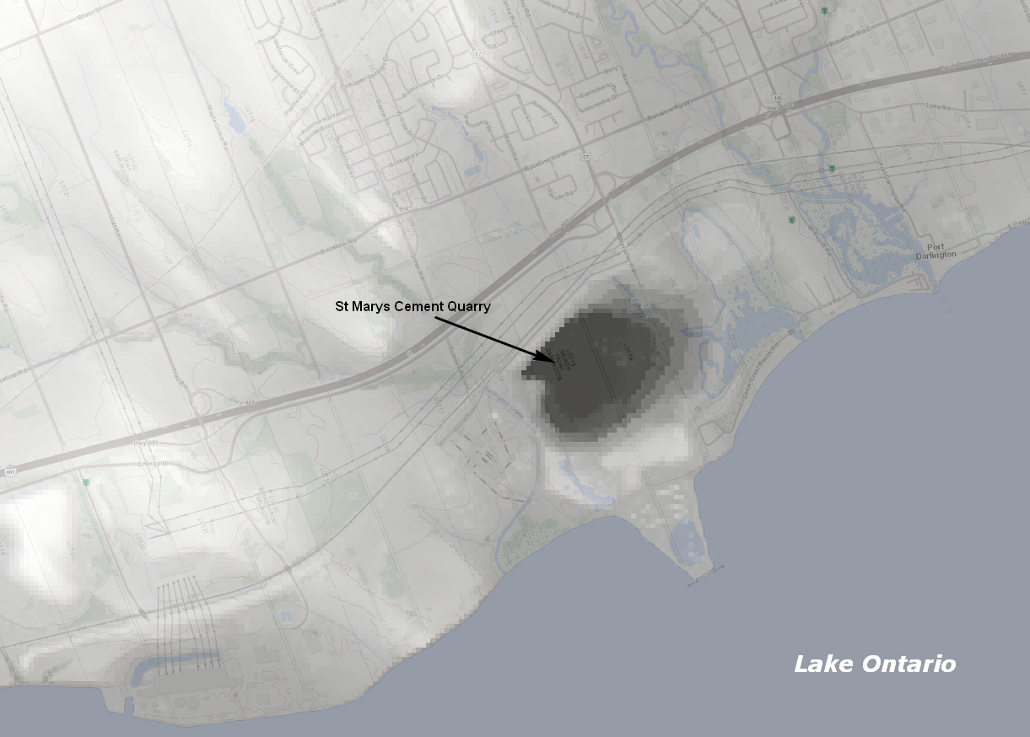
Figure 2: Location of St Marys Cement Quarry – the lowest point in southern Ontario – approximately 78m below the average level of nearby Lake Ontario

Horizontal Reference System

Horizontal Datum and Coordinate System
The horizontal datum and coordinate system used for the data is North American Datum 1983 (NAD83) / Ontario MNRF Lambert. This datum and coordinate system are defined within the European Petroleum Survey Group’s (EPSG) Geodetic Parameter Registry (Code 3161) (http://www.epsg-registry.org/). The following parameters are used in association with the coordinate system:
- False Easting: 930000.00
- False Northing: 6430000.00
- Central Meridian: -85.00
- 1st Standard Parallel: 44.50
- 2nd Standard Parallel: 53.50
- Latitude of Origin: 0.00
- Linear Unit: Metres
The LCC projection provides minimal distortion for shape, area and direction with scale being accurate along the standard parallels and is best suited for representing broader regions up to a latitude range of 35 degrees (ESRI, 2013). As only one coordinate system and set of parameters are required, the entire province can be effectively represented using one spatial resolution.

Horizontal Unit of Measure (coordinate system axis units)
The horizontal unit of measure is metres (m).

Vertical Reference System

Vertical Coordinate System
The vertical datum of the DEM is based on the Canadian Geodetic Vertical Datum 1928 (CGVD28) of the Geodetic Survey Division and is measured in metres above MSL. This datum is defined within the European Petroleum Survey Group’s (EPSG) Geodetic Parameter Registry (Code 5713) (http://www.epsg-registry.org/).

Vertical Unit of Measure (coordinate system axis units)
The vertical unit of measure for all raster grid cells in the DEM is metres (m). One single vertical elevation value is associated with each raster grid cell in the DEM.

Data Delivery
The PDEM and metadata are currently stored and distributed through Land Information Ontario (LIO) (http://www.ontario.ca/page/land-information-ontario). Metadata and distribution packages for the PDEM can be accessed through the Ontario GeoHub website.
(https://geohub.lio.gov.on.ca/search?q=PDEM)
If you navigate to the landing page of Ontario GeoHub, you can also type in “PDEM” when searching to bring up the record.
(https://geohub.lio.gov.on.ca)
The physical data is available for download as two GeoTIFF files labelled “PDEM North” and “PDEM South” (see Figure 1). Each GeoTIFF file is approximately 2 gigabytes in size when zipped. There is also ‘PDEM – Boundary’ polygon shape file available for download which outlines the tiled extents of the PDEM.
When using the GeoTIFF for the first time, building an overview pyramid file (extension .OVR) is recommended for significantly faster viewing and rendering in GIS software applications. For ArcGIS users, under ArcCatalog, simply right-click the raster, select Build Pyramids… and accept the default options for best performance. It should take only a couple minutes to generate. ArcMap may also prompt you to build pyramids when first adding the DEM to the project. If you click OK, pyramids will be built based on how your Raster Storage options are set under the Environment Settings. If you are unsure of these settings, click Cancel and build manually as described above.
Pyramid Setting Tips:
- “NEAREST” resampling is preferred for non-discrete data since this technique is the fastest for generating pyramids. The other resampling methods employ a weighting or averaging based on neighbouring values, which is not necessary if the primary use for pyramids here is display performance.
- You may choose to further compress the pyramid file, but little advantage will be gained for floating point data and rendering may in fact be slower accessing highly compressed pyramid files.
- For other GIS software, please consult the appropriate help documentation for properly generating an overview pyramid file.
In ArcMap, we also recommend building statistics for each DEM tile to accurately display the elevation range in the symbology. Changing the settings Symbology > Statistics to “From Current Display Extent”, and Symbology > Stretch to “Percent Clip” will give the best contrast dynamically at any scale. You can also use the Image Analysis Window to dynamically create hill shades or other derivatives if you desire. Consult your specific software package help documentation for the appropriate optimum display settings.

Elevation Products Available in Ontario
In October of 2014, PMU released the ‘Ontario Elevation Data Index’. It allows users to discover the extents and the metadata associated for elevation products within the province of Ontario. To discover the index and view all the available elevation products check out the Ontario Elevation Data Index page on the LIO Metadata Management Tool. (https://www.javacoeapp.lrc.gov.on.ca/geonetwork?uuid=5577a80d-e092-42a4b8b5-10dd2c3cd33c)
- Elevation Sources and Interpolation

Source Elevation Data
The PDEM was created to provide a broad scale elevation data product that most closely represents true ground elevations where possible. The PDEM was constructed using several data sources to provide seamless coverage for the entire province. These data sources and their extents are illustrated in Figure 3. The ‘PDEM Spatial Metadata Index’ is also available for download from the PDEM metadata page on LIO Metadata Management Tool website (see Data Delivery section). Consult this dataset for the most up-to-date version because the image portrayed in Figure 3 may not always reflect the latest updates, and the figure’s small scale does not allow for a clear depiction of where all the updates occurred.
Table 1: Key fields in the PDEM Spatial Metadata Index. The ‘Raster Update Date’ (RAS_UPD_DT) field tells the user when a particular area was updated.
Key Field Name | Data Type | Description
OBJECTID | LONG INTEGER | Feature identifier.
RAS_UPD_DT | DATE | Date when data source was incorporated into the PDEM. Full Name: Raster Update Date.
SqKm | DOUBLE | Area in square kilometres.
Source | DOUBLE | The elevation data source name, interpolation method (if necessary), and/or the year the data source was acquired.

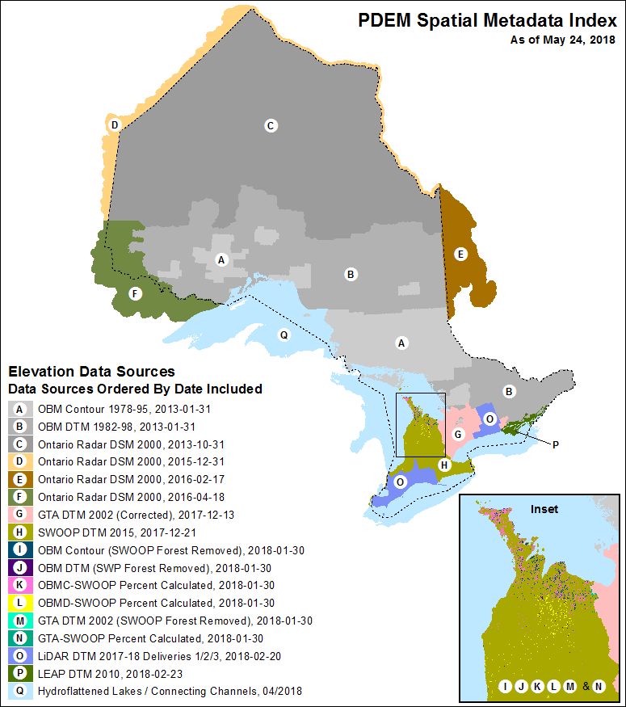
Figure 3: Extent of source elevation datasets used to create the PDEM. The inset shows where SWOOP forest surfaces were modified with OBM or GTA DTM data sources. Note this is strictly for illustrative purposes. Please consult the PDEM Spatial Metadata Index layer in LIO for the most current and accurate depiction of the product.

Ontario Basic Mapping Elevation Data
As the ministry continues to acquire new elevation data in different areas of the province, the vintage OBM data which currently exists in the PDEM will gradually be replaced. In this release of the product, southwestern Ontario has now been updated with more recent acquisitions. Central Ontario may soon follow suit with data acquired through the Forest Resource Inventory program depending on its suitability to represent true ground.
Elevation base data acquired through the OBM program between 1976 and 1996 was interpreted using traditional stereo plotter photogrammetric techniques (for more information on the acquisition history, download the “OBM Photo Block Index” from the Data Distribution section of the LIO metadata page). Data was captured at a scale of 1:10,000 in southern Ontario and 1:20,000 in northern Ontario based on the data capture specifications (MNRF, 1994).
Table 2 provides scales, accuracy and mapping specifications for the OBM data. Even though these specifications pertain to OBM, the stated accuracies can serve as a guide for the other data sources as well. In particular the ORDSM described in the next section is comparable in scale and accuracy. The newer data sources will have significantly greater accuracy in their native resolutions. However, when they are generalized to a 30m resolution, the range in elevation over 30m pixels can be highly variable particularly in steep terrain resulting in an accuracy in some areas that is more consistent with the regional data sources (MNRF, 2020a).
All OBM data was initially captured using the Universal Transverse Mercator (UTM) projection within four UTM Zones (Zones 15, 16, 17 and 18). Elevation data was originally captured using the North American Datum 1927 (NAD27) but has been subsequently converted to the GO-ITS Standard datum of North American Datum 1983 (NAD83) using the National Transformation Version 2 (NTv2) specifications.

Table 2: Ontario Basic Mapping specifications (adapted from MNRF, 1994)
Specification | Southern Ontario | Northern Ontario
Nominal Scale of Photography | 1:30,000 | 1:50,000
Nominal Scale of Mapping | 1:10,000 | 1:20,000
Absolute Positional Accuracy | 5 metres | 10 metres
Absolute Vertical Accuracy (contours & DTM) | 2.5 metres | 5 metres
Contour Interval | 5 metres | 10 metres
DTM Elevation Point Spacing (max) | 60 metres | 100 metres
Spot Elevation Point (vertical accuracy) | 1.25 metres | 2.5 metres

Ontario Radar DSM (ORDSM)
Coverage in northern Ontario has been sourced from 1 arc-second spaceborne C-band interferometric radar data acquired by NASA from the 2000 Shuttle Radar Topography Mission (SRTM), which was used to create the ORDSM data product (see Figure 3). During product construction, the spatial resolution and geospatial coordinate system was made consistent with the PDEM, which allowed for the elevation to be integrated seamlessly. It should be noted that, unlike the other source elevation data mentioned, elevation values in SRTM based data sources are more influenced by vegetation and other surface features which reduces the accuracy of representing true ground elevations. For more information on this data source please refer to the ORDSM metadata (MNRF, 2012b).

All Other Elevation Updates
For all newer elevation data sources that were used to update the PDEM (starting with the 2002 GTA product), please consult the appropriate holding in LIO for detailed information concerning these products. For data improvements and methods used to compile the PDEM, please refer to the ‘PDEM Technical Report’ available for download from the LIO metadata page (MNRF, 2020a).

Water Bodies
A consistent lake and river flattening process was applied to the Great Lakes, the Connecting Channels and the upper St. Lawrence River, which respects the long-term average lake and river levels observed by NOAA and FOC-CHS binational partners. Since the Niagara River is not a navigable river, it is not as rigorously monitored by these agencies, and therefore a different method using orthophotography breaklines was employed. Data sources included 2002 GTA breaklines (Ontario side) and 2010 SWOOP breaklines (U.S. side). For more information, please refer to the ‘PDEM Technical Report’ (MNRF, 2020a).
The lower St. Lawrence River (from the foot of the Iroquois Dam to the Ontario border) used an older method to adjust shoreline elevations which involved the creation of a ‘Great Lake Shoreline Contour’ dataset. The contour was derived from the original OBM representation of the water body edge and the elevation values were extrapolated from nearby OBM spot heights within the water body. The accuracy of these points could not be validated without proper control, so the adjustments were based on the interpreter’s best judgement in ensuring a downward trend along the shoreline edge. As a result, some anomalies may also exist along the interface between where the Great Lakes and upper St. Lawrence were later flattened and the adjacent inland cells that may have been previously adjusted by the Great Lake Shoreline Contour dataset in areas where OBM still exists. These areas would include the Lake Huron shoreline, St. Marys River, Lake Superior shoreline, the St. Lawrence River and select islands. New enhanced FRI data sources or similar large-scale acquisitions in the future, are expected to rectify this issue where it may exist.
Where possible, shoreline elevations for inland water bodies have also been included across the province where OBM still exists. Lake elevations were photogrammetrically captured during the OBM program and included within the OBM Spot Height dataset. Actual elevations within these lakes are not necessarily maintained as areas of constant elevation (i.e. flat surfaces) when replaced by a new data source.
For other areas of the province, different techniques for lake and river flattening were employed depending on the acquisition (this includes ORDSM/SRTM and large-scale data sources). Not all features were flattened, a decision that was typically based on a minimum width criterion. Please consult each data holding in LIO for more information on the acquisition specifications used where available.

Forest Vegetation
Some data sources may not represent true ground in some cases and behave more like a DSM capturing the top of features (e.g. tree canopy, building rooftops, and so on).
As mentioned earlier, the SRTM/ORDSM data product is one example where this may be evident particularly in dense vegetation cover. Little can be done here to rectify the situation without a proper baseline for comparison for the majority of the far north of Ontario.
The SWOOP 2015 data product is another example where capturing true ground elevation through pixel autocorrelation was not always possible. This is particularly the case in the Bruce Peninsula / Beaver Valley region where dense vegetation cover is predominant. However, there are multiple data sources to draw upon here for potential validation and correction. The OBM data product, for example, was relatively good in capturing significant trends in the terrain. Even though the OBM is considered a vintage dataset and may not reflect current conditions, the Bruce Peninsula / Beaver Valley region is a largely protected natural landscape with distinct morphology which has changed very little over time since the OBM elevation data was acquired.
Therefore, the SWOOP product was validated against the OBM and areas that were significantly different often occurred where there was dense forest cover. Areas greater than 10 metres difference were completely replaced by OBM derived elevation. In areas between 4 to 10 metres difference, a percentage gradation or weighting was applied to smooth out the transition between SWOOP and OBM data sources (see the inset of Figure 3 for the area where this enhancement was applied). The end result was an improved elevation product which better represented true ground in this area. For more details on how this enhancement was conducted, please refer to the ‘PDEM Technical Report’ (MNRF, 2020a).
- Recommended Data Uses and Considerations

Recommended Data Uses
The PDEM has several important applications and uses where true ground elevations are required especially along riparian channels and other areas altered in the hydro-enforcement process. Some suitable uses include:
- Generating slope and aspect derived products;
- Querying elevation values in a given area, such as a watershed unit;
- As a reference or input dataset for predictive mapping associated with the study or mapping of surficial geology, land cover, morphology, and terrestrial and aquatic ecology; and,
- Where users prefer to apply their own hydrology enforcement techniques to address site-specific issues not addressed in the Ontario Integrated Hydrology (OIH) data product, the PDEM can serve as a suitable input data source.
MNRF uses the PDEM for several broad scale applications and serves as a useful reference and source dataset in the compilation of OIH, OHN, and Ontario’s land cover products to name just a few.

Considerations

DEM Interpolation
The PDEM employs various interpolation techniques including:
- ANUDEM/ESRI Topogrid spline interpolation for areas covered by OBM;
- ESRI Local Polynomial Interpolation (LPI) algorithm for areas covered by SRTM (MNRF, 2012b); and,
- ESRI Bilinear Resampling of finer resolution DTM’s derived from more recent large-scale elevation data acquisitions. Please refer to the ‘PDEM Technical Report’ for more information on methods employed (MNRF, 2020a).
It is the responsibility of the user to determine if the PDEM is suitable for their application or whether another product should be used. To obtain information on other elevation data products available within the province, please refer to the LIO Metadata Management Tool website (click the ‘Elevation’ link for a list of data or lookup the Ontario Elevation Data Index). If you require further assistance, please contact PMU at pmu@ontario.ca.

Raster Merging and Mosaicking
When two or more raster datasets need to be assembled together to cover a specific study area a raster merge or mosaic function must be used. The method typically employed for the PDEM is the ‘Path of Least Difference’ or the ESRI Least Cost Path method as it is referred to in ArcGIS (ESRI, 2016). This allows for a smooth transition along the raster boundaries with only a minor amount of interpolation along a one-cell wide overlap between different data sources. For more information on this method, please refer to the ‘PDEM Technical Report’ (MNRF, 2020a) or ‘User Guide for Least Cost Path Analysis Tool’ (MNRF, 2020b).

DEM Maintenance
Ongoing maintenance will continue with the PDEM product to address errors and data improvements over time. Updates will include the incorporation of large-scale elevation products that become available for certain areas of the province to improve vertical accuracy and to better represent current conditions where possible. This will depend on feasibility or expressed need and suitability for incorporation. In some areas a change detection analysis could be used to determine if the current PDEM needs to be updated, depending on the magnitude of change. Large scale elevation data would need to be re-processed or resampled into a suitable medium scale data product before incorporating into the PDEM. For more information, please refer to the ‘PDEM Technical Report’ (MNRF, 2020a).

- References

General References
ESRI, 2016. Creating the least cost path, ArcGIS Help 10.3, Environmental Science Research Institute. (http://desktop.arcgis.com/en/arcmap/10.3/tools/spatial-analyst-toolbox/creating-the-least-cost-path.htm)
ESRI, 2013. ArcGIS Desktop 9.3 Help – Lambert Conformal Conic, Environmental Science Research Institute. (http://webhelp.esri.com/arcgisdesktop/9.3/index.cfm?TopicName=Lambert_Conformal_Conic)
MNRF, 2008. Provincial DEM Version 2.0.0 Product Specification. Geographic Information Branch, Science and Information Resources
Division, Ontario Ministry of Natural Resources, 25p.
Zhao, J., Todd, K., Hogg, A. and Kenny, F. 2008. Improving Ontario’s Digital Elevation Model, Internal Report. Water Resources Information Program, Ontario Ministry of Natural Resources, 90p.

Guideline References
MNRF, 1994. Ontario Government Specifications for the Delivery of Digital Topographic Data and Cartographic Representation Products at Medium Scales. Geographic Information Branch, Science and Information Resources Division, Ontario Ministry of Natural Resources, 59p.

Metadata References and Resources
MNRF, 2012a. Ontario Integrated Hydrology Data, Metadata record. Mapping and Information Resources Branch, Ontario Ministry of Natural Resources and Forestry. (https://geohub.lio.gov.on.ca/search?q=OIH)
MNRF, 2012b. Ontario Radar DSM, Metadata record. Mapping and Information Resources Branch, Ontario Ministry of Natural Resources and Forestry. (https://geohub.lio.gov.on.ca/search?q="Ontario Radar DSM")
MNRF, 2020a. Provincial Digital Elevation Model (PDEM) Methods and Processes Technical Report. Provincial Mapping Unit, Mapping and Information Resources Branch, Ontario Ministry of Natural Resources and Forestry.
MNRF, 2020b. Updating Provincial Elevation Data Using Least Cost Path Analysis Technical Report. Provincial Mapping Unit, Mapping and Information Resources Branch, Ontario Ministry of Natural Resources and Forestry.
(https://geohub.lio.gov.on.ca/search?q=PDEM)

Version 1516.

All new data sources acquired by the province are not necessarily incorporated and are evaluated in terms of available resources, the perceived benefits, and the return on investment for supporting the suite of derived products produced by the province.
The PDEM Technical Report is expected to be published over the summer of 2018. In the interim, contact PMU for more information.

