- Log into myUwindsor.
- Click on the mySuccess tab in the top left corner of the myUwindsor home page (see image below).
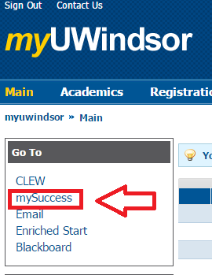
- Log into mySuccess with the same username and password you used for myUwindsor.
- Click on the ‘Writing Support’ tab in the top left corner (see image below).
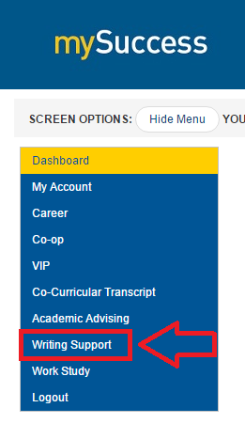
- Click on the ‘Appointments’ tab that appears beneath the ‘Writing Support’ tab (see image below).
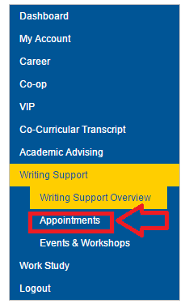
- Click on the ‘View Calendar’ option that appears to the right of the menu (see image below).
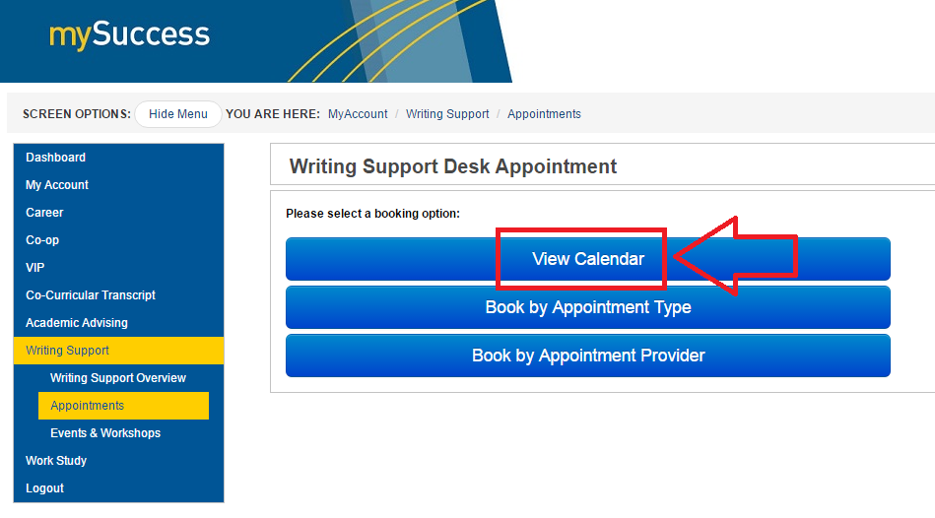
- On the calendar that pops up, select the appointment that you want to cancel (see image below).
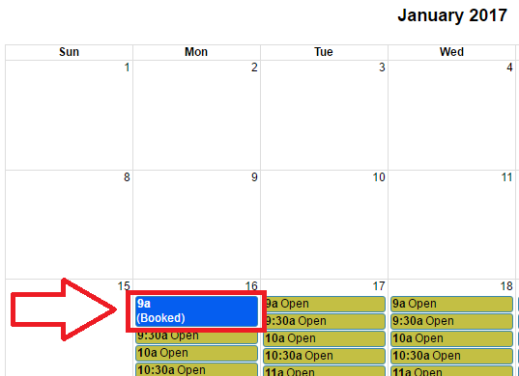
- On the page that shows up, press the red ‘Cancellation’ button at the top of the form (see image below).
