- Log into myUwindsor.
- Click on the mySuccess tab in the top left corner of the myUwindsor home page (see image below).
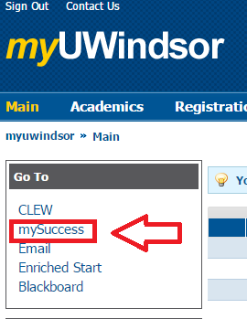
- Log into mySuccess with the same username and password you used for myUwindsor.
- Click on the ‘Writing Support’ tab in the top left corner (see image below).
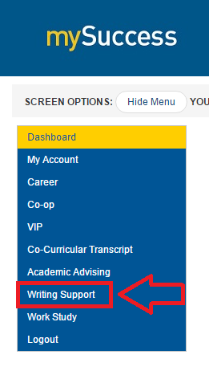
- Click on the ‘Appointments’ tab that appears beneath the ‘Writing Support’ tab (see image below).
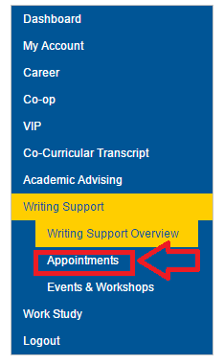
- Click on the ‘View Calendar’ option that appears to the right of the menu (see image below).
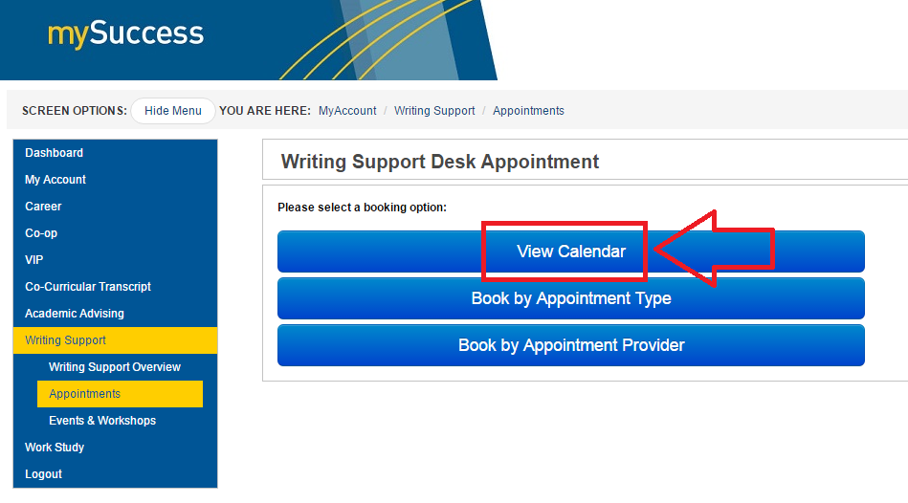
- On the calendar that pops up, select the appointment that works best for you. They will which appear as beige, horizontal rectangles (see image below). When you hover over the appointment, it will tell you which advisor the appointment will be with.
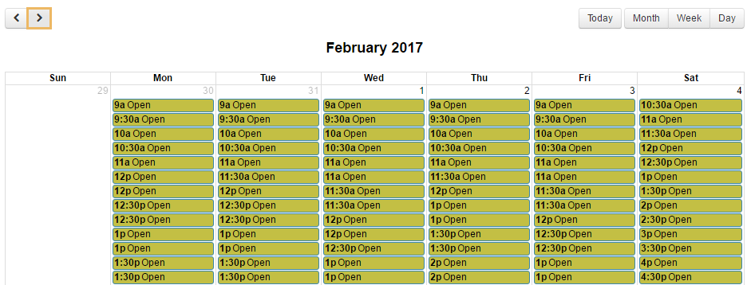
- On the page that shows up, select what you are looking for help with from the list under the words ‘Additional Information’ (the list is squared off in green in the image below). Paste the items in to the box found on the right (squared off in blue in the image below). Then click the ‘Book Appointment’ button below the form (squared off in red in the image below).
